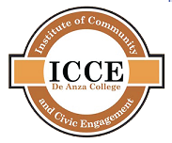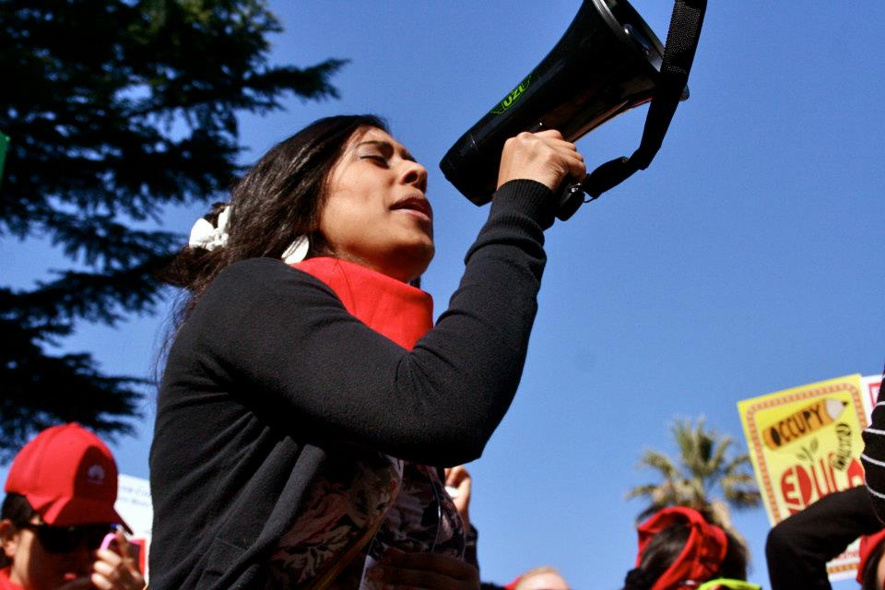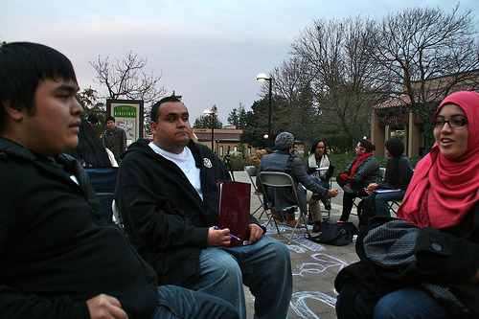

You can choose classes from the list below and put together your own approach to the program. Complete the following minimum number of units in each of the four categories:

**Leadership and Power: 4 units**

|  |  |  |
| --- | --- | --- |
| SOSC 17/  WMST 17 | Grassroots Democracy: Leadership and Power | (4) |

**Leadership Skills: 4 units**

|  |  |  |
| --- | --- | --- |
| BUS 65 | Leadership | (5) |
| ES 66 | Environmental Leadership | (1) |
| ES 67 | Environmental Team-Building | (1) |
| ES 68 | Community-Based Coalitions and Stakeholders | (1) |
| ICS 55 | Civic Leadership for Community Empowerment | (4) |
| SPCH 15 | Critical Decision Making in Groups | (4) |
| SPCH 70 | Effective Organizational Communication | (4) |

**Understanding Social Change: 4 units**

|  |  |  |
| --- | --- | --- |
| ICS 17/  PHIL 17 | Critical Consciousness and Social Change | (4) |
| POLI 15/  WMST 15 | Grassroots Democracy: Race, Culture, and Liberation | (4) |
| POLI 16/  WMST 16 | Grassroots Democracy: Social Movements Since the 1960s | (4) |
| SOC 5 | Sociology of Globalization and Social Change | (4) |
| ICS 55 | Civic Leadership for Community Empowerment | (4) |
| SPCH 15 | Critical Decision Making in Groups | (4) |
| SPCH 70 | Effective Organizational Communication | (4) |

**Leadership Internship: 6 units**

|  |  |  |
| --- | --- | --- |
| ICS 80 series | Community Based Learning in Intercultural Studies: ICS 80, 80W, 80X, 80Y, 80Z | (o.5-4) |
| LART 80 series | Community Based Learning in Language Arts:  LART 80, 80W, 80X, 80Y, 80Z | (o.5-4) |
| SOSC 80 series | Community Based Learning in Social Sciences: SOSC 80, 80W, 80X, 80Y, 80Z | (o.5-4) |

**Total Units Required: 18**

# Recommended English courses:

# In addition to required certificate courses, we recommend taking LEAD! EWRT and ELIT classes which are engagement-based and service-oriented English classes. For more information, go to www.deanza.edu/lead.

# Option B: Independent

**Institute of Community and Civic Engagement**

**De Anza College**

**21250 Stevens Creek Blvd.**

**Cupertino, CA 95014**

Office: East Cottage

Phone: (408) 864-5559

E-mail: icce@deanza.edu

Web: www.deanza.edu/communityengagement

www.facebook.com/groups/civicengagement/

**CERTIFICATE IN LEADERSHIP AND**

**SOCIAL CHANGE**

at De Anza College

Upon completion, students will be able to:

* Analyze the social processes that foster inequality and disempowerment, and those that challenge inequality and lead to empowerment.
* Analyze the ways that social processes are amenable to transformation through strategic planning and constituent mobilization.
* Apply leadership skills, such as meeting facilitation, strategic planning, consensus-building, and generating buy-in from stakeholders, with the aim of fostering social justice and empowerment.

### ICCE Mission

The Institute of Community and Civic Engagement works to empower students to become agents of change in their communities and beyond; to foster education that meets the needs of the communities we serve; and to help develop pathways to meaningful participation in local, state, and federal government decision making processes.

### Certificate of Achievement in Leadership and Social Change

This certificate prepares students to be community leaders, agents of change, and responsible participants in civic life in general. They will gain in-depth understanding of the social structures that define their worlds, and develop the skills and practical knowledge required to transform those structures and make the world a more equitable place.

# Option A: Cohort

A cohort of students takes a specified set of classes together as a group each quarter. This option is recommended as there is mentoring and a stronger sense of community among students.

**Fall:**

I. “Critical Consciousness and Social Change”

PHIL/ICS 17 (4 units)

II. “Community Based Learning in Intercultural Studies”

ICS 80X (2 units)

**Winter:**

I. “Grassroots Democracy: Leadership and Power”

SOSC/WMST 17 (4 units)

II. “Community Based Learning in Intercultural Studies”

ICS 80X (2 units)

**Spring:**

I. “Civic Leadership for Community Empowerment”

ICS 55 (4 units)

II. “Community Based Learning in Intercultural Studies”

ICS 80X (2 units)

### Why get this certificate?

* Universities, businesses, and community organizations are constantly looking for students ready to take leadership on the campus, in the workplace, and in the community.
* Students completing this certificate will be prepared to work as an entry-level union organizer or staff person at a non-profit organization.
* For those looking to transfer to a four-year institution, the certificate can help build your application as colleges look for engaged students with experience working in the community.
* The knowledge and experience acquired can be applied to any situation you will find yourself in.
* Our hope is that students passionate about social justice will be able to use this certificate to find meaningful work in order to make a better world for all of us.

# Student Learning Outcomes

Certificate of Achievement in Leadership and Social Change

Institute of Community and Civic Engagement