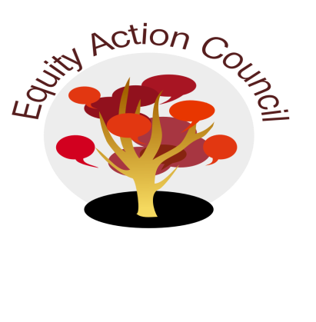
Time | Topic | Process | Facilitator(s)
1:30 pm | Introduction | Conocimiento and Check In: Cultural Ways of Healing | Edmundo Norte
1:45 pm | Updates | - Cultural Humility Workshops  - Food, Housing and Transportation Student Survey  - End of Year Celebrations  - Title IX - Dr. Stacey Shears | Alicia Cortez
2:10pm |  | - Equity Vision and Voice Working Session | Edmundo & Alicia
2:30pm |  | - Equity Champion Criteria and Timeline | Alicia Cortez
2:50pm | Closure | - Announcements  - Appreciations | All

EAC Community Agreements
Show up, and choose to be present
Pay attention to what has heart and meaning
Tell the truth without blame or judgment
Be open to outcome, not attached to outcome
From The Four-Fold Way® by Angeles Arrien, Ph.D.

