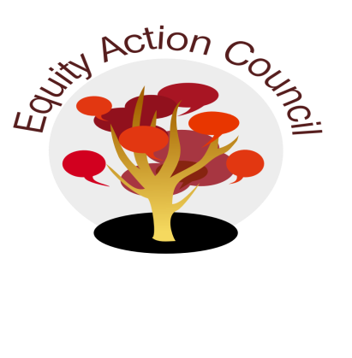
Time | Topic | Process | Facilitator(s)
1:30 pm | Introduction  Conocimiento | Welcome and Introductions | Edmundo Norte
 |  | Brief Social Justice Creation Stories | Everyone
2:00 pm | Updates | Equity Action Council  - Structure Revamp Update | Edmundo Norte
 |  | Equity and Engagement Division –  - Recent Hate Crime and Institutional Response + Community Response  - Follow up on the series on hate crimes  - Immigration Raids and Responses | Edmundo Norte  Danny Acosta  Angelica Esquivel
 |  | Office of Equity  - Equity Core Team Session  - Sharing High Impact Practices | Tony Santa Ana
 |  | Guided Pathways | Edmundo Norte
2:45pm | Closure | - Announcements  - Closing Appreciations | All

EAC Community Agreements
Show up, and choose to be present
Pay attention to what has heart and meaning
Tell the truth without blame or judgment
Be open to outcome, not attached to outcome
From The Four-Fold Way® by Angeles Arrien, Ph.D.

