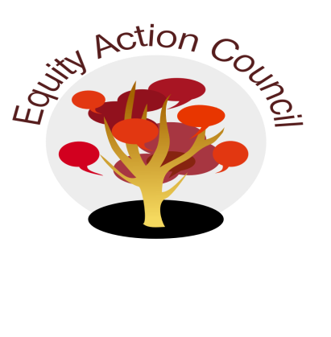
Time | Topic | Process | Facilitator(s)
1:30pm | Introduction | - Welcome  - Mindfulness Activity | Edmundo Norte + Alicia Cortez
1:40pm | Update | - EAC Reaffirmation Statement Subcommittee Report | Alicia Cortez
1:45pm | Guests | - Student Voices in Shared Governance (See Attached Document) | Elias Kamal, Past Student Trustee
 |  | - Food Insecurity on College Campuses | Ben Falter, SJSU
2:45pm | Closure | - Announcements  - Appreciations | All

EAC Community Agreements
Show up, and choose to be present
Pay attention to what has heart and meaning
Tell the truth without blame or judgment
Be open to outcome, not attached to outcome
From The Four-Fold Way® by Angeles Arrien, Ph.D.

