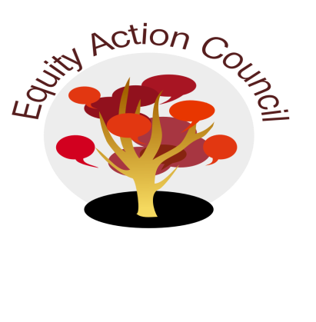
Time | Topic | Process | Facilitator(s)
1:30 pm | I | I. Introduction: Conocimiento and Check In | Edmundo Norte
1:45 pm | I | II. Review EAC Agreements | Alicia Cortez
1:55 pm | I | III. Institutional Metrics - small group activity | Alicia Cortez
2:05 pm | I/D/A | IV. Subcommittee Report:  - DASB/ICC (Steffany Djuarsa, And Doan)  - Equity Champion Award ( Erick Aragon, Hyon Chu Yi-Baker & Adriana Garcia)  - Technology Advisory (Sandy Cordoza)  - Outreach Conferences- Latinx - (Erick Aragon)
2:35pm | I | V. Compassion and Care Dialogue - | Melissa Aguilar & Others
2:45pm | I | - Announcements  - March 15 [10am-2:30pm @ MLC 250]: Mental Health First Aid  - March 19 [10:30am-12:30pm] Meet and Greet for Trans Students  - March 19 [1:30-3:30pm + May 16 [12:30-2:30pm] Cultural Humility by Veronica Neal  - March 20: Community Care 11am-1pm @ MLC250 1:30-3:30pm @ MLC 113  - March 21: 11:30am-1:30pm Chican/Latina Foundation Scholarship App Workshop  - Appreciations | All

EAC Community Agreements
Show up, and choose to be present
Pay attention to what has heart and meaning
Tell the truth without blame or judgment
Be open to outcome, not attached to outcome
From The Four-Fold Way® by Angeles Arrien, Ph.D.

