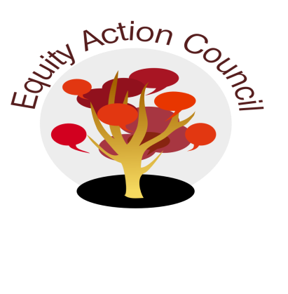
Time | Process | Topic | Facilitator(s)
1:30-1:45pm | I | I. Introduction: Conocimiento and Check In | Edmundo Norte
1:45-1:50pm | I/D/A | II. Subcommittee Report:  - DASB/ICC (Steffani Djuarsa, And Doan)  - Equity Champion Award ( Erick Aragon, Hyon Chu Yi-Baker & Adriana Garcia)  - Technology Advisory (Sandy Cordoza)  - District Book Club  - NCORE Conference | Representatives
1:50 to 2:00pm | I | III. District Diversity and Equity Advisory Committee | Alicia Cortez  Karen Chow
2:00-2:10pm | D/A | IV. Student Voice in Governance | Melissa Aguilar  Rex Zhang
2:10-2:35pm | I | V. Appreciative Inquiry by University of Utah Doctoral Student (Guest) | Edmundo Norte  Sean Crossland
2:35-2:50pm | I/D/A | VI. Updated Student Equity Plan Draft - http://deanza.edu/ir/planning/index.html | Alicia Cortez
2:50pm | I | VII. Announcements & Appreciations | Erick Aragon

EAC Community Agreements
Show up, and choose to be present
Pay attention to what has heart and meaning
Tell the truth without blame or judgment
Be open to outcome, not attached to outcome
From The Four-Fold Way® by Angeles Arrien, Ph.D.

